Name: Shruti Uday Dhavale Roll No:27

LAB EXERCISE 01

Implement rational number as new data type.

#include <stdio.h>
# include <conio.h>
struct Rational {
int num;
int den;
};
int main() {
struct Rational r1, r2, sum;
int res;
clrscr();
printf("Enter numerator and denominator for first rational number: ");
scanf("%d %d", &r1.num, &r1.den);
printf("Enter numerator and denominator for second rational number: ");
scanf("%d %d", &r2.num, &r2.den);
// Addition formula: (a/b) + (c/d) = (ad + bc) / bd

sum.num = r1.num * r2.den + r2.num * r1.den;
sum.den = r1.den * r2.den;
res = sum.num/sum.den;
printf("%d/%d + %d/%d",r1.num,r1.den,r2.num,r2.den);
printf("\n Sum = %d",res);
getch();
}
Output:-
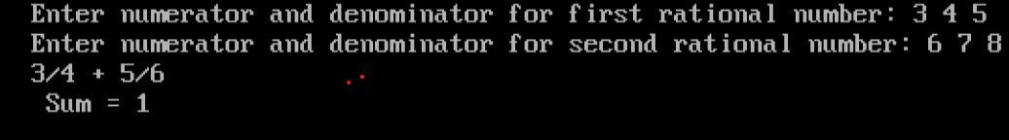

Name :Shruti Uday Dhavale Roll No:27

LAB EXERCISE 02

Implement complex number as new data type.

#include <stdio.h>
# include <conio.h>
struct Complex {
float real;
float imag;
};
int main() {
struct Complex c1, c2, sum;
clrscr();
printf("Enter real and imaginary part of first complex number: ");
scanf("%f %f", &c1.real, &c1.imag);
printf("Enter real and imaginary part of second complex number: ");
scanf("%f %f", &c2.real, &c2.imag);
sum.real = c1.real + c2.real;
sum.imag = c1.imag + c2.imag;
printf("Sum = %.2f + %.2fi\n", sum.real, sum.imag);
getch();
}

Output:- 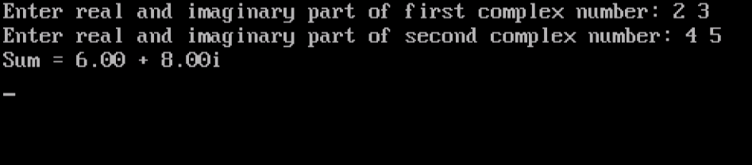

Name: Shruti uday Dhavale Roll No:27

LAB EXERCISE 03

Write your own function for string operations.

#include<stdio.h>
int strlength(char str[]);
void strcopy(char s1[],char s2[]);
void strconcat(char s1[], char s2[]);
int strcompare(char s1[], char s2[]);
void strreverse(char str[]);
int main()
{
char str1[100], str2[100];
int choice,result;
while(1)
{
printf("\n String operations Menu\n");
printf("1. Length\n");
printf("2. Copy\n");
printf("3. concatinate\n");
printf("4. compare\n");
printf("5. Reverse\n");
printf("6. Exit\n");
printf("\n Enter your choice:");
scanf("%d",&choice)
switch(choice)
{
case 1:
printf("Enter String:");
scanf("%s",str1);
printf("Length = %d\n",strlength(str1));
break;
case 2:
printf("\n Enter source string:");
scanf("%s",str1);
strcopy(str2, str1);
printf("Copid string: %s\n", str2);
break;
case 3:
printf("Enter first string:");
scanf("%s",str1);
printf("Enter second string:");
scanf("%s",str2);
strconcat(str1,str2);
printf("Concatinated string: %s\n",str1);
break
case 4:
printf("Enter first string:");
scanf("%s",str1);
printf("Enter second string:");
scanf("%s",str2);
result = strcompare(str1, str2);
if(result == 0)
printf("Strings are equal");
else
printf("Strings are not equal");
break;
case 5:
printf("Enter String:");
scanf("%s",str1);
strreverse(str1);
printf("Reversed String: %s\n", str1);
break;
case 6:
return 0;
default:
printf("Invalid choice\n");
}
}
}
int strlength(char str[])
{
int i = 0;
while(str[i] != '\0')
i++;
return i;
}
void strcopy(char s1[], char s2[])
{
int i = 0;
while(s2[i] != '\0')
{
s1[i] = s2[i];
i++;
}
s1[i] = '\0';
}
void strconcat(char s1[], char s2[])
{
int i = 0, j = 0;
while(s1[j] != '\0')
i++;
while(s2[j] != '\0')
{
s1[i] = s2[j];
i++;
j++;
}
s1[i] = '\0';
}
int strcompare(char s1[], char s2[])
{
int i = 0;
while(s1[i] == s2[i])
{
if(s1[i] == '\0')
return 0;
i++;
}
return 1;
}
void strreverse(char str[])
{
int i, j;
char temp;
i = 0;
j = strlength(str) -1;

while(i < j)
{
temp = str[i];
str[i] = str[j];
str[j] = temp;
i++;
j--;
}
}
Output:-

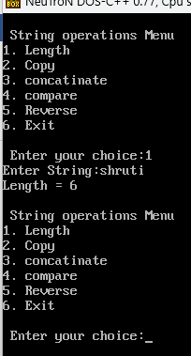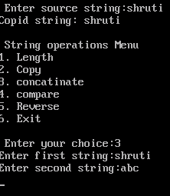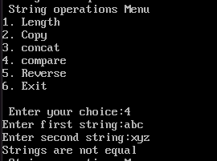

Name: Shruti uday Dhavale Roll No:27

LAB EXERCISE 04

Implement matrix as new data type
#include <stdio.h>
# include <conio.h>
struct Matrix {
int row;
int col;
int data[10][10];
};
void main() {
struct Matrix m1, m2, sum;
int i, j;
clrscr();
printf("Enter rows and columns: ");
scanf("%d %d", &m1.row, &m1.col);
m2.row = sum.row = m1.row;
m2.col = sum.col = m1.col;
printf("Enter elements of first matrix:\n");
for(i = 0; i < m1.row; i++) {
for(j = 0; j < m1.col; j++) {
scanf("%d", &m1.data[i][j]);
}
}
printf("Enter elements of second matrix:\n");
for(i = 0; i < m2.row; i++) {
for(j = 0; j < m2.col; j++) {
scanf("%d", &m2.data[i][j]);
}
}
for(i = 0; i < sum.row; i++) {
for(j = 0; j < sum.col; j++) {
sum.data[i][j] = m1.data[i][j] + m2.data[i][j];
}
}
printf("First matrices:\n");
for(i = 0; i < m1.row; i++) {
for(j = 0; j < m1.col; j++) {
printf("%d ", m1.data[i][j]);
}
printf("\n");
}
printf("Second matrices:\n");
for(i = 0; i < m2.row; i++) {
for(j = 0; j < m2.col; j++) {
printf("%d ", m2.data[i][j]);
}

printf("\n");
}
printf("Sum of matrices:\n");
for(i = 0; i < sum.row; i++) {
for(j = 0; j < sum.col; j++) {
printf("%d ", sum.data[i][j]);
}
printf("\n");
}
getch();
}

Output:-

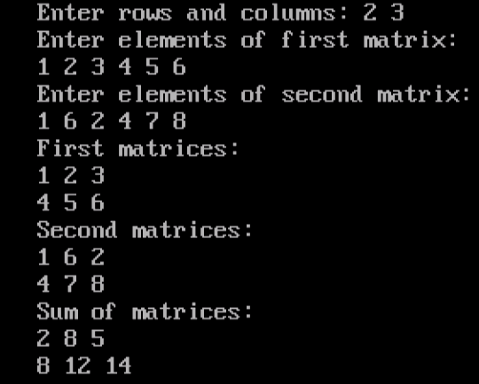

Name: Shruti uday Dhavale Roll No:27

LAB EXERCISE 05
Implement stack using array
#include<stdio.h>
# include <conio.h>
// Stack using array
int stack[100],choice,n,top,x,i;
void push(void);
void pop(void);
void display(void);
int main()
{
clrscr();
top=-1;
printf("\n Enter the size of STACK[MAX=100]:");
scanf("%d",&n);
printf("\n\t STACK OPERATIONS USING ARRAY");
printf("\n\t--------------------------------");
printf("\n\t 1.PUSH\n\t 2.POP\n\t 3.DISPLAY\n\t 4.EXIT");
do
{
printf("\n Enter the Choice:");
scanf("%d",&choice);
switch(choice)
{
case 1:
{
push();
break;
}
case 2:
{
pop();
break;
}
case 3:
{
display();
break;
}
case 4:
{
printf("\n\t EXIT POINT ");
break;
}
default:
{
printf ("\n\t Please Enter a Valid Choice(1/2/3/4)");
}
}
}
while(choice!=4);
return 0;
}
void push()
{
if(top>=n-1)
{
printf("\n\tSTACK is over flow");
}
else
{
printf(" Enter a value to be pushed:");
scanf("%d",&x);
top++;
stack[top]=x;
}
}
void pop()
{
if(top<=-1)
{
printf("\n\t Stack is under flow");
}
else
{
printf("\n\t The popped elements is %d",stack[top]);
top--;
}
}
void display()
{
if(top>=0)
{
printf("\n The elements in STACK \n");
for(i=top; i>=0; i--)
printf("\n%d",stack[i]);
printf("\n Press Next Choice");
}
else
{
printf("\n The STACK is empty");
}
}

Output:-

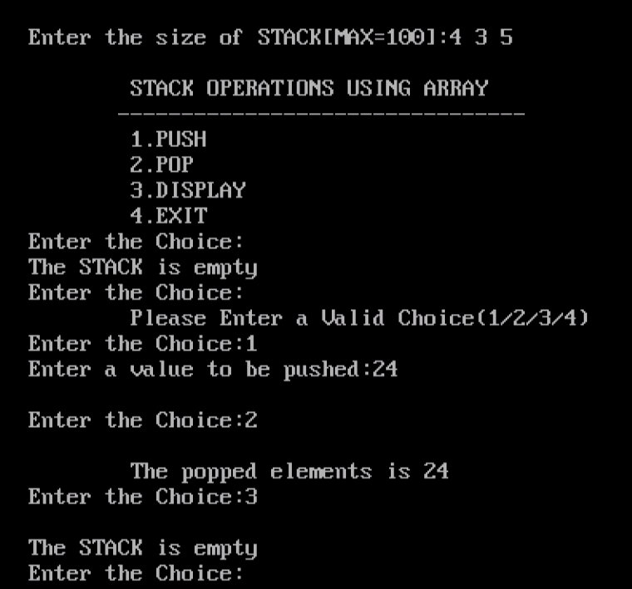

Name: Shruti uday Dhavale Roll No:27

LAB EXERCISE 06

Implement stack using linked list

#include <stdio.h>
#include <stdlib.h>
// Define structure
struct node {
int data;
struct node* next;
};
struct node* top = NULL;
// PUSH Operation
void push(int value) {
struct node* newnode;
newnode = (struct node*)malloc(sizeof(struct node));
if (newnode == NULL) {
printf("Stack Overflow\n");
} else {
newnode->data = value;
newnode->next = top;
top = newnode;
printf("Inserted: %d\n", value);
}
}
void pop() {
if (top == NULL) {
printf("Stack Underflow\n");
} else {
struct node* temp = top;
printf("Deleted: %d\n", temp->data);
top = top->next;
free(temp);
}
}
void display() {
struct node* temp = top;
if (temp == NULL) {
printf("Stack is Empty\n");
} else {
printf("Stack elements:\n");
while (temp != NULL) {
printf("%d\n", temp->data);
temp = temp->next;
}
}
}
void peek() {
if (top == NULL) {
printf("Stack is Empty\n");
} else {
printf("Top element: %d\n", top->data);
}
}
int main() {
int choice, value;
while (1) {
printf("\n1.Push 2.Pop 3.Display 4.Peek 5.Exit\n");
printf("Enter choice: ");
scanf("%d", &choice);
switch (choice) {
case 1:
printf("Enter value: ");
scanf("%d", &value);
push(value);
break;
case 2:
pop();
break;
case 3:
display();
break;
case 4:
peek();
break;
case 5:
return 0;
default:
printf("Invalid choice\n");
}
}
}
Output:-
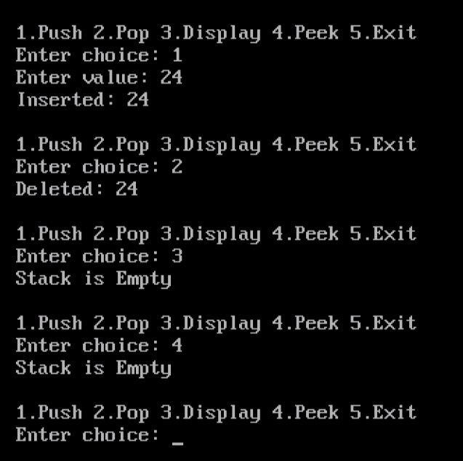

Name: Shruti uday Dhavale Roll No:27

LAB EXERCISE 07

Using of stack for checking brackets in mathematical expression

#include <stdio.h>
#include <string.h>
# include<conio.h>
# include <conio.h>
#define MAX 100
// Match Paranthesis
char stack[MAX];
int top = -1;
void push(char ch)
{
stack[++top] = ch;
}
char pop()
{
return stack[top--];
}
int isMatchingPair(char open, char close)
{
if(open == '(' && close == ')') return 1;
if(open == '{' && close == '}') return 1;
if(open == '[' && close == ']') return 1;
return 0;
}
int main()
{
char exp[100];
int i;
printf("Enter expression: ");
scanf("%s", exp);
for(i = 0; exp[i] != '\0'; i++)
{
if(exp[i] == '(' || exp[i] == '{' || exp[i] == '[')
push(exp[i]);
else if(exp[i] == ')' || exp[i] == '}' || exp[i] == ']')
{
if(top == -1 || !isMatchingPair(pop(), exp[i]))
{
printf("Not Balanced\n");
return 0;
}
}
}
if(top == -1)
printf("Balanced\n");
else
printf("Not Balanced\n");
getch();
}

Output:-

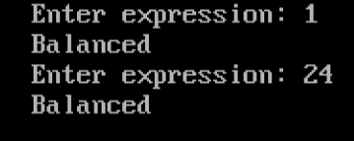

Name: Shruti uday Dhavale Roll No:27

LAB EXERCISE 08

Conversion of infix to postfix expression
#include <stdio.h>
#include <ctype.h>
#include <string.h>
#include <conio.h>
#define MAX 100
// Infix to postfix
char stack[MAX];
int top = -1;
void push(char ch)
{
stack[++top] = ch;
}
char pop()
{
return stack[top--];
}
int precedence(char op)
{ if(op == '+' || op == '-') return 1;
if(op == '*' || op == '/') return 2;
if(op == '^') return 3;
return 0;
}
int main()
{
char infix[100], postfix[100];
int i, j = 0;
printf("Enter infix expression: ");
scanf("%s", infix);
for(i = 0; infix[i] != '\0'; i++)
{
if(isalnum(infix[i]))
postfix[j++] = infix[i];
else if(infix[i] == '(')
push(infix[i]);
else if(infix[i] == ')')
{
while(stack[top] != '(')
postfix[j++] = pop();
pop();
}
else
{
while(top != -1 && precedence(stack[top]) >= precedence(infix[i]))
postfix[j++] = pop();
push(infix[i]);
}
}
while(top != -1)
postfix[j++] = pop();
postfix[j] = '\0';
printf("Postfix Expression: %s\n", postfix);
getch();
}
Output:-

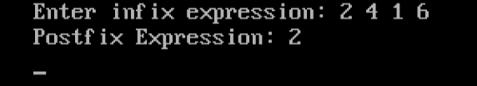

Name: Shruti uday Dhavale Roll No:27

LAB EXERCISE 09

Evaluation of postfix expression.
#include <stdio.h>
#include <ctype.h>
#define MAX 100
/ /Experssion eval
int stack[MAX];
int top = -1;
// Push
void push(int val) {
stack[++top] = val;
}
// Pop
int pop() {
return stack[top--];
}
int main() {
char exp[100];
int i, op1, op2, result;
printf("Enter postfix expression: ");
scanf("%s", exp);
for(i = 0; exp[i] != '\0'; i++) {
// If operand (digit)
if(isdigit(exp[i])) {
push(exp[i] - '0'); // convert char to int
}
else {
op2 = pop();
op1 = pop();
switch(exp[i]) {
case '+':
result = op1 + op2;
break;
case '-':
result = op1 - op2;
break;
case '*':
result = op1 * op2;
break;
case '/':
result = op1 / op2;
break;
}
push(result);
}
}
printf("Result = %d", pop());
return 0;
}
Output:-

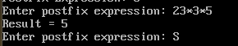

Name: Shruti uday Dhavale Roll No:27

LAB EXERCISE 10

Implementation of queue using array

#include <stdio.h>
# include <conio.h>
#define MAX 5
int queue[MAX];
int front = -1, rear = -1;
// Enqueue
void enqueue() {
int value;
if (rear == MAX - 1) {
printf("Queue Overflow\n");
} else {
printf("Enter value: ");
scanf("%d", &value);
if (front == -1)
front = 0;
queue[++rear] = value;
printf("Inserted: %d\n", value);
}
}
void dequeue() {
if (front == -1 || front > rear) {
printf("Queue Underflow\n");
} else {
printf("Deleted: %d\n", queue[front]);
front++;
}
}
void display() {
if (front == -1 || front > rear) {
printf("Queue is empty\n");
} else {
int i;
printf("Queue elements: ");
for ( i = front; i <= rear; i++) {
printf("%d ", queue[i])}
printf("\n");
}
}
int main() {
int choice;
do {
printf("\n--- Queue Menu ---\n");
printf("1. Enqueue\n");
printf("2. Dequeue\n");
printf("3. Display\n");
printf("4. Exit\n");
printf("Enter your choice: ");
scanf("%d", &choice);
switch (choice) {
case 1:
enqueue();
break;
case 2:
dequeue();
break;
case 3:
display();
break;
case 4:
printf("Exiting...\n");
break;
default:
printf("Invalid choice\n");
}
} while (choice != 4);
return 0;
}

Output:-
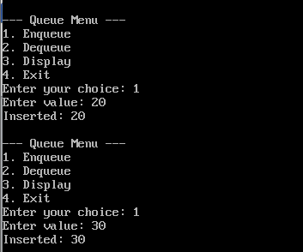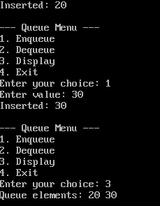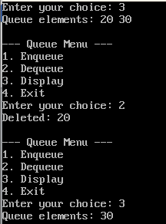



Name: Shruti uday Dhavale Roll No:27
LAB EXERCISE 11

Implementation of queue using linked list.
#include <stdio.h>
#include <stdlib.h>

// Queue using Linked List
struct node {
int data;
struct node *next;
};

struct node *front = NULL, *rear = NULL;

// Enqueue
void enqueue() {
struct node *newnode;
newnode = (struct node*)malloc(sizeof(struct node));

printf("Enter data: ");
scanf("%d", &newnode->data);

newnode->next = NULL;

if (rear == NULL) {
front = rear = newnode;
} else {
rear->next = newnode;
rear = newnode;
}

printf("Element inserted!\n");
}

// Dequeue
void dequeue() {
struct node *temp;

if (front == NULL) {
printf("Queue is empty!\n");
} else {
temp = front;
front = front->next;

if (front == NULL) {
rear = NULL;
}

printf("Deleted element: %d\n", temp->data);
free(temp);
}
}

// Display
void display() {
struct node *temp;

if (front == NULL) {
printf("Queue is empty!\n");
} else {
temp = front;
printf("Queue: ");
while (temp != NULL) {
printf("%d -> ", temp->data);
temp = temp->next;
}
printf("NULL\n");
}
}

// Main Menu
int main() {
int choice;

do {
printf("\n--- QUEUE MENU ---\n");
printf("1. Enqueue\n");
printf("2. Dequeue\n");
printf("3. Display\n");
printf("4. Exit\n");

printf("Enter choice: ");
scanf("%d", &choice);

switch (choice) {
case 1:
enqueue();
break;

case 2:
dequeue();
break;

case 3:
display();
break;

case 4:
printf("Exit...\n");
break;

default:
printf("Invalid choice!\n");
}

} while (choice != 4);

return 0;
}

Output:

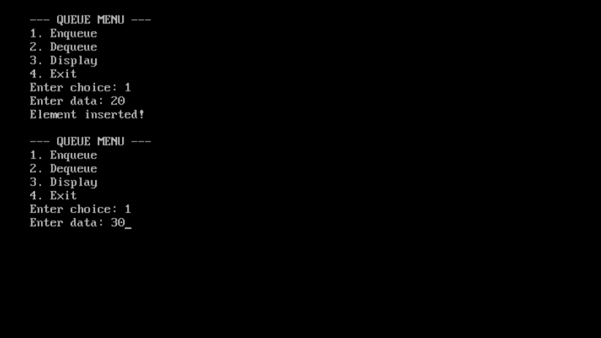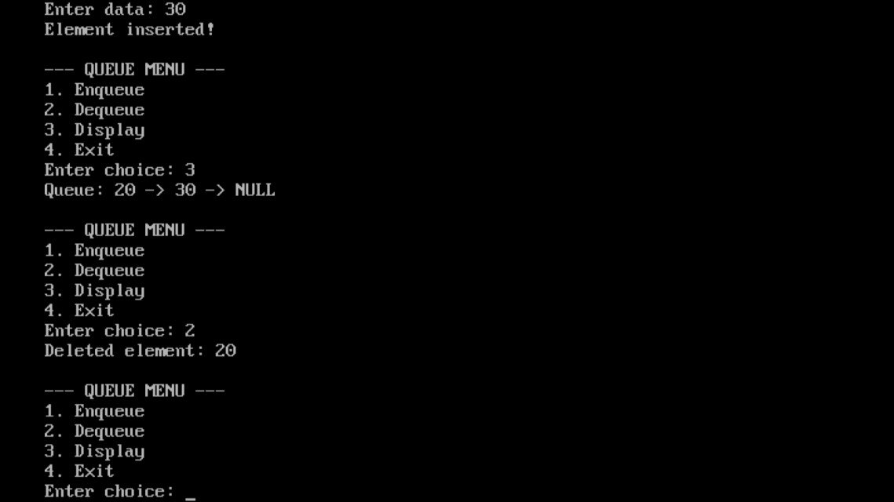

Name: Shruti uday Dhavale Roll No:27
LAB EXERCISE 12

12. Implementation of priority queue.

#include <stdio.h>
#define MAX 5
// Priority Queue using array
int value[MAX];
int priority[MAX];
int size = 0;
// Insert
void insert() {
int val, pr;

if (size == MAX) {
printf("\nQueue Overflow\n");
return;
}
printf("Enter Value: ");
scanf("%d", &val);

printf("Enter Priority: ");
scanf("%d", &pr);

value[size] = val;
priority[size] = pr;
size++;
printf("Element inserted successfully!\n");
}
// Delete (Highest priority first)
void deleteElement() {
int highest = 0;
int i;

if (size == 0) {
printf("\nQueue Underflow\n");
return;
}
for (i = 1; i < size; i++) {
if (priority[i] > priority[highest]) {
highest = i;
}
}
printf("\nDeleted Element: Value=%d Priority=%d\n",
value[highest], priority[highest]);

// Shift elements
for (i = highest; i < size - 1; i++) {
value[i] = value[i + 1];
priority[i] = priority[i + 1];
size--;
}
// Display
void display() {
int i;
if (size == 0) {
printf("\nQueue is empty\n");
return;
}
printf("\nPriority Queue:\n");
for (i = 0; i < size; i++) {
printf("Value=%d Priority=%d\n", value[i], priority[i]);
}
}
int main() {
int choice;

do {
printf("\n--- PRIORITY QUEUE MENU ---\n");
printf("1. Insert\n");
printf("2. Delete\n");
printf("3. Display\n");
printf("4. Exit\n");
printf("Enter your choice: ");
scanf("%d", &choice);
switch (choice) {
case 1:
insert();
break;
case 2:
deleteElement();
break;
case 3:
display();
break;

case 4:
printf("Exiting...\n");
break;

default:
printf("Invalid choice!\n");
}

} while (choice != 4);

return 0;
}

Output:-

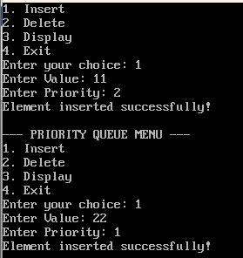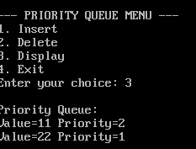
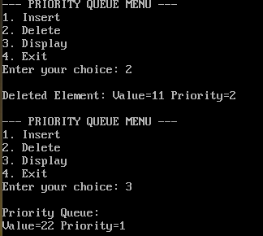

Name: Shruti uday Dhavale Roll No:27

LAB EXERCISE 13

Implementation of Dqueue
#include <stdio.h>
#include <stdlib.h>
#define MAX 5
// Double Ended Queue
int dq[MAX];
int front = -1, rear = -1;

// Insert at Front
void insertFront(int x) {

if ((front == 0 && rear == MAX - 1) || (front == rear + 1)) {
printf("Overflow\n");
return;
}
if (front == -1)
front = rear = 0;

else if (front == 0)
front = MAX - 1;

else
front--;

dq[front] = x;

printf("Inserted at front\n");
}
// Insert at Rear
void insertRear(int x) {

if ((front == 0 && rear == MAX - 1) || (front == rear + 1)) {
printf("Overflow\n");
return;
}
if (rear == -1)
front = rear = 0;
else if (rear == MAX - 1)
rear = 0;
else
rear++;

dq[rear] = x;

printf("Inserted at rear\n");
}
// Delete from Front
void deleteFront() {

if (front == -1) {
printf("Underflow\n");
return;
}
printf("Deleted: %d\n", dq[front]);

if (front == rear)
front = rear = -1;

else if (front == MAX - 1)
front = 0;

else
front++;
}
// Delete from Rear
void deleteRear() {

if (rear == -1) {
printf("Underflow\n");
return;
}
printf("Deleted: %d\n", dq[rear]);

if (front == rear)
front = rear = -1;

else if (rear == 0)
rear = MAX - 1;

else
rear--;
}

// Display
void display() {

int i;

if (front == -1) {
printf("Deque is empty\n");
return;
}
printf("Deque: ");

i = front;

while (1) {
printf("%d ", dq[i]);

if (i == rear)
break;

i = (i + 1) % MAX;
}
printf("\n");
printf("\nFront = %d, Rear = %d\n", front, rear);
}
// Main Menu
int main() {

int choice, value;

while (1) {

printf("\n--- DEQUE MENU ---\n");
printf("1. Insert Front\n");
printf("2. Insert Rear\n");
printf("3. Delete Front\n");
printf("4. Delete Rear\n");
printf("5. Display\n");
printf("6. Exit\n");

printf("Enter choice: ");
scanf("%d", &choice);
switch (choice) {

case 1:
printf("Enter value: ");
scanf("%d", &value);

insertFront(value);
break;

case 2:
printf("Enter value: ");
scanf("%d", &value);

insertRear(value);
break;

case 3:
deleteFront();
break;

case 4:
deleteRear();
break;

case 5:
display();
break;

case 6:
printf("Exiting...\n");
exit(0);

default:
printf("Invalid choice\n");
}
}
return 0;
}

Output:-

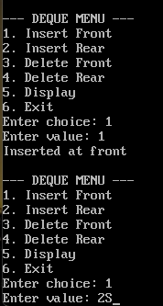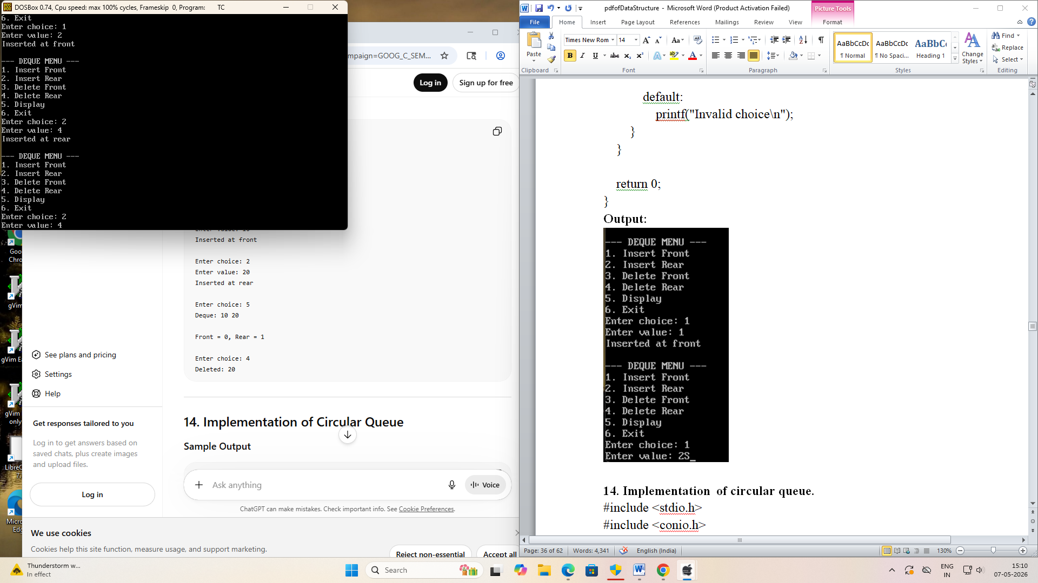

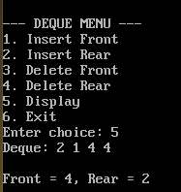

Name: Shruti uday Dhavale Roll No:27

LAB EXERCISE 14

Implementation of circular queue
#include <stdio.h>
#include <conio.h>
#define MAX 5
// Circular Queue using Array
int queue[MAX];
int front = -1, rear = -1;
// Enqueue Operation
void enqueue(int value) {

if ((rear + 1) % MAX == front) {
printf("Queue Overflow\n");
}
else {
// First element
if (front == -1)
front = 0;
rear = (rear + 1) % MAX;
queue[rear] = value;

printf("Inserted: %d\n", value);
}
}
// Dequeue Operation
void dequeue() {

if (front == -1) {
printf("Queue Underflow\n");
}
else {

printf("Deleted: %d\n", queue[front]);
// Queue becomes empty
if (front == rear) {
front = rear = -1;
}
else {
front = (front + 1) % MAX;
}
}
}
// Display Operation
void display() {

if (front == -1) {
printf("Queue is Empty\n");
}
else {
int i = front;

printf("Queue elements: ");
while (1) {
printf("%d ", queue[i]);

if (i == rear)
break;

i = (i + 1) % MAX;
}
printf("\n");
}
}
// Main Function
int main() {
int choice, value;
clrscr();
while (1) {

printf("\n1.Enqueue 2.Dequeue 3.Display 4.Exit\n");
printf("Enter choice: ");
scanf("%d", &choice);
switch (choice) {
case 1:
printf("Enter value: ");
scanf("%d", &value);
enqueue(value);
break;

case 2:
dequeue();
break;
case 3:
display();
break;
case 4:
return 0;
default:
printf("Invalid choice\n");
}
}
}

Output:-

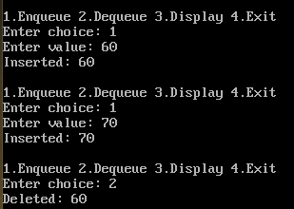

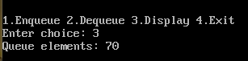

Name: Shruti uday Dhavale Roll No:27

LAB EXERCISE 15
Implementation of singly linked list
#include <stdio.h>
#include <stdlib.h>
// Unit 3: Single linked list
// Node structure
struct node {
int data;
struct node *next;
};
struct node *head = NULL;
// Insert at Beginning
void insert_begin(int value) {
struct node *newnode;
newnode = (struct node*)malloc(sizeof(struct node));
newnode->data = value;
newnode->next = head;
head = newnode;
printf("Inserted at beginning\n");
}
// Insert at End
void insert_end(int value) {
struct node *newnode, *temp;
newnode = (struct node*)malloc(sizeof(struct node));
newnode->data = value;
newnode->next = NULL;
if(head == NULL) {
head = newnode;
} else {
temp = head;
while(temp->next != NULL) {
temp = temp->next;
}
temp->next = newnode;
}

printf("Inserted at end\n");
}

// Delete from Beginning
void delete_begin() {
struct node *temp;
if(head == NULL) {
printf("List is empty\n");
return;
}
temp = head;
head = head->next;
free(temp);
printf("Deleted from beginning\n");
}
// Delete from End
void delete_end() {
struct node *temp, *prev;

if(head == NULL) {
printf("List is empty\n");
return;
}
// Only one node
if(head->next == NULL) {
free(head);
head = NULL;
printf("Deleted last node\n");
return;
}
temp = head;

// Traverse to last node
while(temp->next != NULL) {
prev = temp;
temp = temp->next;
}
prev->next = NULL;
free(temp);
printf("Deleted from end\n");
}
// Display (Traversal)
void display() {
struct node *temp = head;

if(temp == NULL) {
printf("List is empty\n");
return;
}
printf("Linked List: ");
while(temp != NULL) {
printf("%d -> ", temp->data);
temp = temp->next;
}
printf("NULL\n");
}
// Main (Menu Driven)
int main() {
int choice, value;
while(1) {
printf("\n--- Single Linked List Menu ---\n");
printf("1. Insert at Beginning\n");
printf("2. Insert at End\n");
printf("3. Delete from Beginning\n");
printf("4. Delete from End\n");
printf("5. Display\n");
printf("6. Exit\n");
printf("Enter your choice: ");
scanf("%d", &choice);
switch(choice) {
case 1:
printf("Enter value: ");
scanf("%d", &value);
insert_begin(value);
break;

case 2:
printf("Enter value: ");
scanf("%d", &value);
insert_end(value);
break;

case 3:
delete_begin();
break;
case 4:
delete_end();
break;

case 5:
display();
break;

case 6:
exit(0);
default:
printf("Invalid choice\n");
}
}

return 0;
}

Output:-
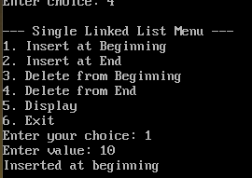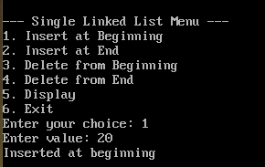
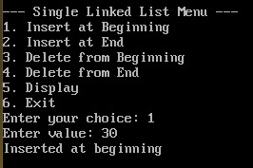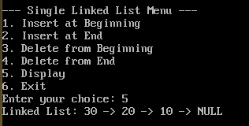

Name: Shruti uday Dhavale Roll No:27

LAB EXERCISE 16

Implementation of singly circularly linked list.

#include <stdio.h>
#include <stdlib.h>
// circular single link list
struct node
{
int data;
struct node *next;
};
struct node *head = NULL;

// Insert at beginning
void insert_begin(int value)
{
struct node *newnode, *temp;
newnode = (struct node*)malloc(sizeof(struct node));
newnode->data = value;

if(head == NULL)
{
head = newnode;
newnode->next = head;
}
else
{
temp = head;
while(temp->next != head)
temp = temp->next;

newnode->next = head;
temp->next = newnode;
head = newnode;
}
}

// Insert at end
void insert_end(int value)
{
struct node *newnode, *temp;
newnode = (struct node*)malloc(sizeof(struct node));
newnode->data = value;

if(head == NULL)
{
head = newnode;
newnode->next = head;
}
else
{
temp = head;
while(temp->next != head)
temp = temp->next;

temp->next = newnode;
newnode->next = head;
}
}
// Delete at beginning
void delete_begin()
{
struct node *temp, *last;

if(head == NULL)
{
printf("List is empty\n");
return;
}

if(head->next == head)
{
free(head);
head = NULL;
}
else
{
temp = head;
last = head;
while(last->next != head)
last = last->next;

head = head->next;
last->next = head;
free(temp);
}
}
// Delete at end
void delete_end()
{
struct node *temp, *prev;

if(head == NULL)
{
printf("List is empty\n");
return;
}
if(head->next == head)
{
free(head);
head = NULL;
}
else
{
temp = head;
while(temp->next != head)
{
prev = temp;
temp = temp->next;
}
prev->next = head;
free(temp);
}
}
// Display list
void display()
{
struct node *temp;

if(head == NULL)
{
printf("List is empty\n");
return;
}

temp = head;
do
{
printf("%d -> ", temp->data);
temp = temp->next;
} while(temp != head);

printf("(head)\n");
}
// Main Menu
int main()
{
int choice, value;
while(1)
{
printf("\n1.Insert Begin\n2.Insert End\n3.Delete Begin\n4.Delete End\n5.Display\n6.Exit\n");
printf("Enter choice: ");
scanf("%d", &choice);

switch(choice)
{
case 1:
printf("Enter value: ");
scanf("%d", &value);
insert_begin(value);
break;

case 2:
printf("Enter value: ");
scanf("%d", &value);
insert_end(value);
break;

case 3:
delete_begin();
break;
case 4:
delete_end();
break;
case 5:
display();
break;
case 6:
exit(0);
default:
printf("Invalid choice\n");
}
}
}

Output:
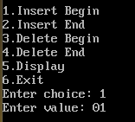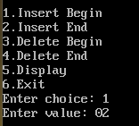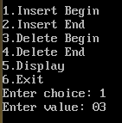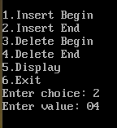
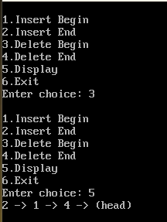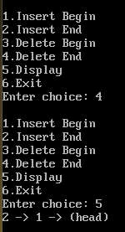

Name: Shruti uday Dhavale Roll No:27

LAB EXERCISE 17

Implementation of doubly linked list.
#include <stdio.h>
#include <stdlib.h>
//doubly linked list
struct node {
int data;
struct node *prev;
struct node *next;
};

struct node *head = NULL;

// Insert at Beginning
void insert_begin() {
struct node *newnode;

newnode = (struct node*)malloc(sizeof(struct node));
printf("Enter data: ");
scanf("%d", &newnode->data);

newnode->prev = NULL;
newnode->next = head;

if(head != NULL) {
head->prev = newnode;
}

head = newnode;

printf("Inserted at beginning!\n");
}

// Insert at End
void insert_end() {
struct node *newnode, *temp;

newnode = (struct node*)malloc(sizeof(struct node));
printf("Enter data: ");
scanf("%d", &newnode->data);

newnode->next = NULL;

if(head == NULL) {
newnode->prev = NULL;
head = newnode;
} else {
temp = head;
while(temp->next != NULL) {
temp = temp->next;
}

temp->next = newnode;
newnode->prev = temp;
}

printf("Inserted at end!\n");
}

// Delete from Beginning
void delete_begin() {
struct node *temp;

if(head == NULL) {
printf("List is empty!\n");
} else {
temp = head;
head = head->next;

if(head != NULL) {
head->prev = NULL;
}

free(temp);
printf("Deleted from beginning!\n");
}
}

// Delete from End
void delete_end() {
struct node *temp;

if(head == NULL) {
printf("List is empty!\n");
} else {
temp = head;

// If only one node
if(temp->next == NULL) {
head = NULL;
free(temp);
} else {
while(temp->next != NULL) {
temp = temp->next;
}

temp->prev->next = NULL;
free(temp);
}

printf("Deleted from end!\n");
}
}

// Display
void display() {
struct node *temp;

if(head == NULL) {
printf("List is empty!\n");
} else {
temp = head;
printf("Doubly Linked List: ");
while(temp != NULL) {
printf("%d <-> ", temp->data);
temp = temp->next;
}
printf("NULL\n");
}
}
// Main Menu
int main() {
int choice;
do {
printf("\n--- DOUBLY LINKED LIST MENU ---\n");
printf("1. Insert at Beginning\n");
printf("2. Insert at End\n");
printf("3. Delete from Beginning\n");
printf("4. Delete from End\n");
printf("5. Display\n");
printf("6. Exit\n");
printf("Enter choice: ");
scanf("%d", &choice);
switch(choice) {
case 1:
insert_begin();
break;
case 2:
insert_end();
break;
case 3:
delete_begin();
break;
case 4:
delete_end();
break;
case 5:
display();
break;
case 6:
printf("Exit...\n");
break;

default:
printf("Invalid choice!\n");
}

} while(choice != 6);

return 0;
}
Output:
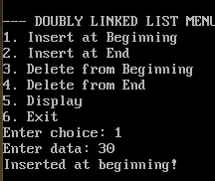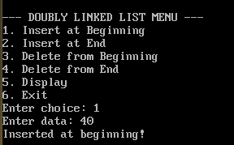
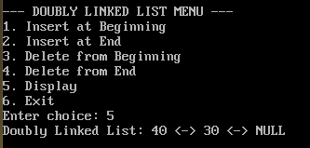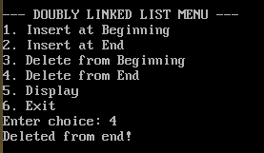

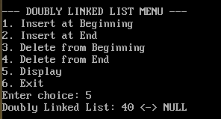

Name: Shruti uday Dhavale Roll No:27

LAB EXERCISE 18

Implementation doubly circularly linked list.

#include <stdio.h>
#include <stdlib.h>
// circular Double Link list
struct node {
int data;
struct node *prev;
struct node *next;
};
struct node *head = NULL;
// Insert at Beginning
void insert_begin() {
struct node *newnode, *last;
newnode = (struct node*)malloc(sizeof(struct node));
printf("Enter data: ");
scanf("%d", &newnode->data);
if(head == NULL) {
newnode->next = newnode;
newnode->prev = newnode;
head = newnode;
} else {
last = head->prev;
newnode->next = head;
newnode->prev = last;
last->next = newnode;
head->prev = newnode;
head = newnode;
}
printf("Inserted at beginning!\n");
}

void insert_end() {
struct node *newnode, *last;
newnode = (struct node*)malloc(sizeof(struct node));
printf("Enter data: ");
scanf("%d", &newnode->data);
if(head == NULL) {
newnode->next = newnode;
newnode->prev = newnode;
head = newnode;
} else {
last = head->prev;
newnode->next = head;
newnode->prev = last;
last->next = newnode;
head->prev = newnode;
}
printf("Inserted at end!\n");
}
void delete_begin() {
struct node *temp, *last;
if(head == NULL) {
printf("List is empty!\n");
} else if(head->next == head) {
free(head);
head = NULL;
} else {
last = head->prev;
temp = head;
head = head->next;
head->prev = last;
last->next = head;
free(temp);
}
printf("Deleted from beginning!\n");
}
void delete_end() {
struct node *last, *second_last;
if(head == NULL) {
printf("List is empty!\n");
} else if(head->next == head) {
free(head);
head = NULL;
} else {
last = head->prev;
second_last = last->prev;
second_last->next = head;
head->prev = second_last;
free(last);
}
printf("Deleted from end!\n");
}
void display() {
struct node *temp;
if(head == NULL) {
printf("List is empty!\n");
} else {
temp = head;
printf("Circular Doubly Linked List: ");
do {
printf("%d <-> ", temp->data);
temp = temp->next;
} while(temp != head);

printf("(back to head)\n");
}
}
int main() {
int choice;
do {
printf("\n--- CDLL MENU ---\n");
printf("1. Insert Begin\n");
printf("2. Insert End\n");
printf("3. Delete Begin\n");
printf("4. Delete End\n");
printf("5. Display\n");
printf("6. Exit\n");
printf("Enter choice: ");
scanf("%d", &choice);
switch(choice) {
case 1: insert_begin(); break;
case 2: insert_end(); break;
case 3: delete_begin(); break;
case 4: delete_end(); break;
case 5: display(); break;
case 6: printf("Exit...\n"); break;
default: printf("Invalid choice!\n");
}
} while(choice != 6);

return 0;
}
Output:-

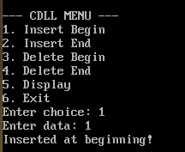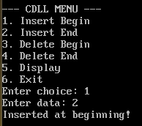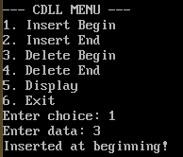
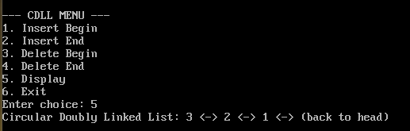
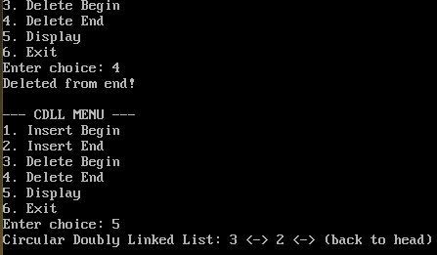

Name: Shruti uday Dhavale Roll No:27

LAB EXERCISE 19
. Solving polynomial arithmetic using linked list

#include <stdio.h>
#include <stdlib.h>
struct node {
int coef, exp;
struct node *next;
};
struct node* create(int coef, int exp) {
struct node *newnode = (struct node*)malloc(sizeof(struct node));
newnode->coef = coef;
newnode->exp = exp;
newnode->next = NULL;
return newnode;
}
struct node* insert(struct node *head, int coef, int exp) {
struct node *temp = head, *newnode = create(coef, exp);
if(head == NULL)
return newnode;
while(temp->next != NULL)
temp = temp->next;
temp->next = newnode;
return head;
}
struct node* add(struct node *p1, struct node *p2) {
struct node *result = NULL;

while(p1 != NULL && p2 != NULL) {
if(p1->exp == p2->exp) {
result = insert(result, p1->coef + p2->coef, p1->exp);
p1 = p1->next;
p2 = p2->next;
}
else if(p1->exp > p2->exp) {
result = insert(result, p1->coef, p1->exp);
p1 = p1->next;
}
else {
result = insert(result, p2->coef, p2->exp);
p2 = p2->next;
}
}
while(p1 != NULL) {
result = insert(result, p1->coef, p1->exp);
p1 = p1->next;
}
while(p2 != NULL) {
result = insert(result, p2->coef, p2->exp);
p2 = p2->next;
}
return result;
}
void display(struct node *head) {
while(head != NULL) {
printf("%dx^%d", head->coef, head->exp);
head = head->next;
if(head != NULL)
printf(" + ");
}
printf("\n");
}

int main() {
struct node *p1 = NULL, *p2 = NULL, *result = NULL;
p1 = insert(p1, 3, 2);
p1 = insert(p1, 2, 1);
p1 = insert(p1, 1, 0);
// Polynomial 2: 5x^2 + 4
p2 = insert(p2, 5, 2);
p2 = insert(p2, 4, 0);
printf("Polynomial 1: ");
display(p1);
printf("Polynomial 2: ");
display(p2);
result = add(p1, p2);
printf("Result: ");
display(result);
return 0;
}

Output:
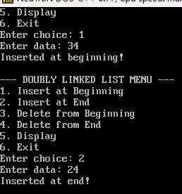

Name: Shruti uday Dhavale Roll No:27

LAB EXERCISE 20

Implementation of binary tree and operations.

#include <stdio.h>
#include <stdlib.h>

struct node
{
int data;
struct node *left, *right;
};

struct node* createNode(int value)
{
struct node* newnode = (struct node*)malloc(sizeof(struct node));

newnode->data = value;
newnode->left = NULL;
newnode->right = NULL;

return newnode;
}

struct node* insert(struct node* root, int value)
{
if(root == NULL)
return createNode(value);

if(value < root->data)
root->left = insert(root->left, value);
else
root->right = insert(root->right, value);

return root;
}

void inorder(struct node* root)
{
if(root != NULL)
{
inorder(root->left);
printf("%d ", root->data);
inorder(root->right);
}
}

void preorder(struct node* root)
{
if(root != NULL)
{
printf("%d ", root->data);
preorder(root->left);
preorder(root->right);
}
}

void postorder(struct node* root)
{
if(root != NULL)
{
postorder(root->left);
postorder(root->right);
printf("%d ", root->data);
}
}

struct node* search(struct node* root, int key)
{
if(root == NULL || root->data == key)
return root;

if(key < root->data)
return search(root->left, key);
else
return search(root->right, key);
}

int main()
{
struct node* root = NULL;
struct node* result;
int choice, value;

do
{
printf("\n1.Insert");
printf("\n2.Inorder");
printf("\n3.Preorder");
printf("\n4.Postorder");
printf("\n5.Search");
printf("\n0.Exit");

printf("\nEnter choice: ");
scanf("%d", &choice);

switch(choice)
{
case 1:
printf("Enter value: ");
scanf("%d", &value);

root = insert(root, value);
break;

case 2:
printf("\nInorder Traversal: ");
inorder(root);
break;

case 3:
printf("\nPreorder Traversal: ");
preorder(root);
break;

case 4:
printf("\nPostorder Traversal: ");
postorder(root);
break;

case 5:
printf("Enter value to search: ");
scanf("%d", &value);

result = search(root, value);

if(result != NULL)
printf("Element Found");
else
printf("Element Not Found");

break;

case 0:
printf("Exit");
break;

default:
printf("Invalid Choice");
}

} while(choice != 0);

return 0;
}
Output:-
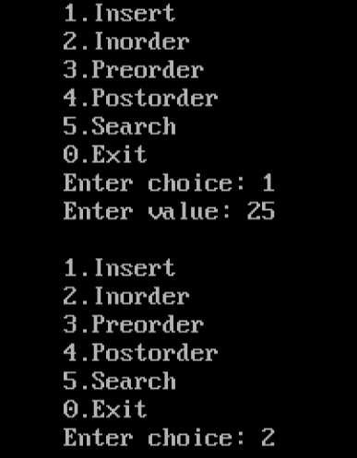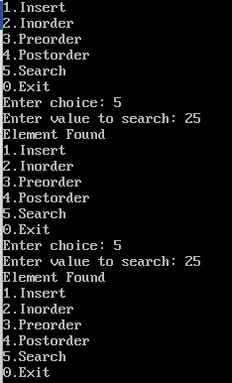

Name: Shruti uday Dhavale Roll No:27

LAB EXERCISE 21
Traversal of binary tree.

#include <stdio.h>
#include <stdlib.h>
struct node {
int data;
struct node *left, *right;
};
struct node* createNode(int value) {
struct node* newNode = (struct node*)malloc(sizeof(struct node));
newNode->data = value;
newNode->left = NULL;
newNode->right = NULL;
return newNode;
}
struct node* insert(struct node* root, int value) {
if (root == NULL)
return createNode(value);
if (value < root->data)
root->left = insert(root->left, value);
else if (value > root->data)
root->right = insert(root->right, value)
return root;
}
// Inorder Traversal (Left, Root, Right)
void inorder(struct node* root) {
if (root != NULL) {
inorder(root->left);
printf("%d ", root->data);
inorder(root->right);
}
}
// Preorder Traversal (Root, Left, Right)
void preorder(struct node* root) {
if (root != NULL) {
printf("%d ", root->data);
preorder(root->left);
preorder(root->right);
}
}
// Postorder Traversal (Left, Right, Root)
void postorder(struct node* root) {
if (root != NULL) {
postorder(root->left);
postorder(root->right);
printf("%d ", root->data);
}
}
struct node* search(struct node* root, int key) {
if (root == NULL || root->data == key)
return root;
if (key < root->data)
return search(root->left, key);
return search(root->right, key);
}
int main() {
struct node* root = NULL;
int choice, value;
struct node* result;
do {
printf("\n1. Insert\n2. Inorder\n3. Preorder\n4. Postorder\n5. Search\n6. Exit\n");
printf("Enter choice: ");
scanf("%d", &choice);
switch (choice) {
case 1:
printf("Enter value: ");
scanf("%d", &value);
root = insert(root, value);
break;
case 2:
printf("Inorder: ");
inorder(root);
printf("\n");
break;
case 3:
printf("Preorder: ");
preorder(root);
printf("\n");
break;
case 4:
printf("Postorder: ");
postorder(root);
printf("\n");
break;
case 5:
printf("Enter value to search: ");
scanf("%d", &value);
result = search(root, value);
if (result != NULL)
printf("Element found!\n");
else
printf("Element not found.\n");
break;
}
} while (choice != 6);
return 0;
}
Output:-
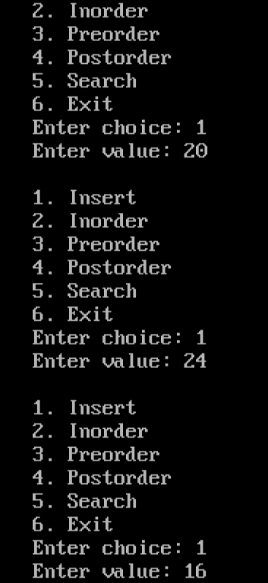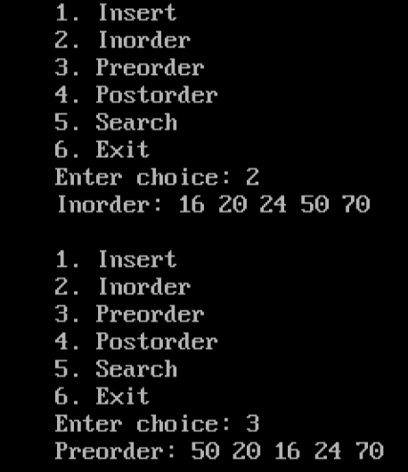
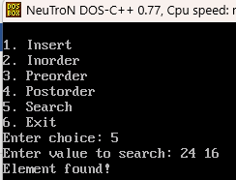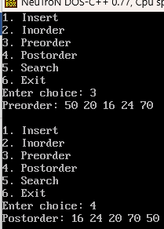

Name: Shruti uday Dhavale Roll No:27

LAB EXERCISE 22

Implementation of hash table.

#include <stdio.h>
#define SIZE 10
int hashTable[SIZE];
// Initialize hash table
void init()
{
int i;

for(i = 0; i < SIZE; i++)
{
hashTable[i] = -1;
}
}
// Hash function
int hashFunction(int key)
{
return key % SIZE;
}
// Insert element
void insert(int key)
{
int index = hashFunction(key);
if(hashTable[index] == -1)
{
hashTable[index] = key;
}
else
{
printf("Collision occurred for key %d at index %d\n",
key, index);
}
}
// Display hash table
void display()
{
int i;
printf("\nHash Table:\n");

for(i = 0; i < SIZE; i++)
{
if(hashTable[i] != -1)
{
printf("Index %d : %d\n", i, hashTable[i]);
}
else
{
printf("Index %d : Empty\n", i);
}
}
}
// Main function
int main()
{
init();
insert(15);
insert(25);
insert(35);
insert(12);
insert(22);

display();

return 0;
}
Output:-
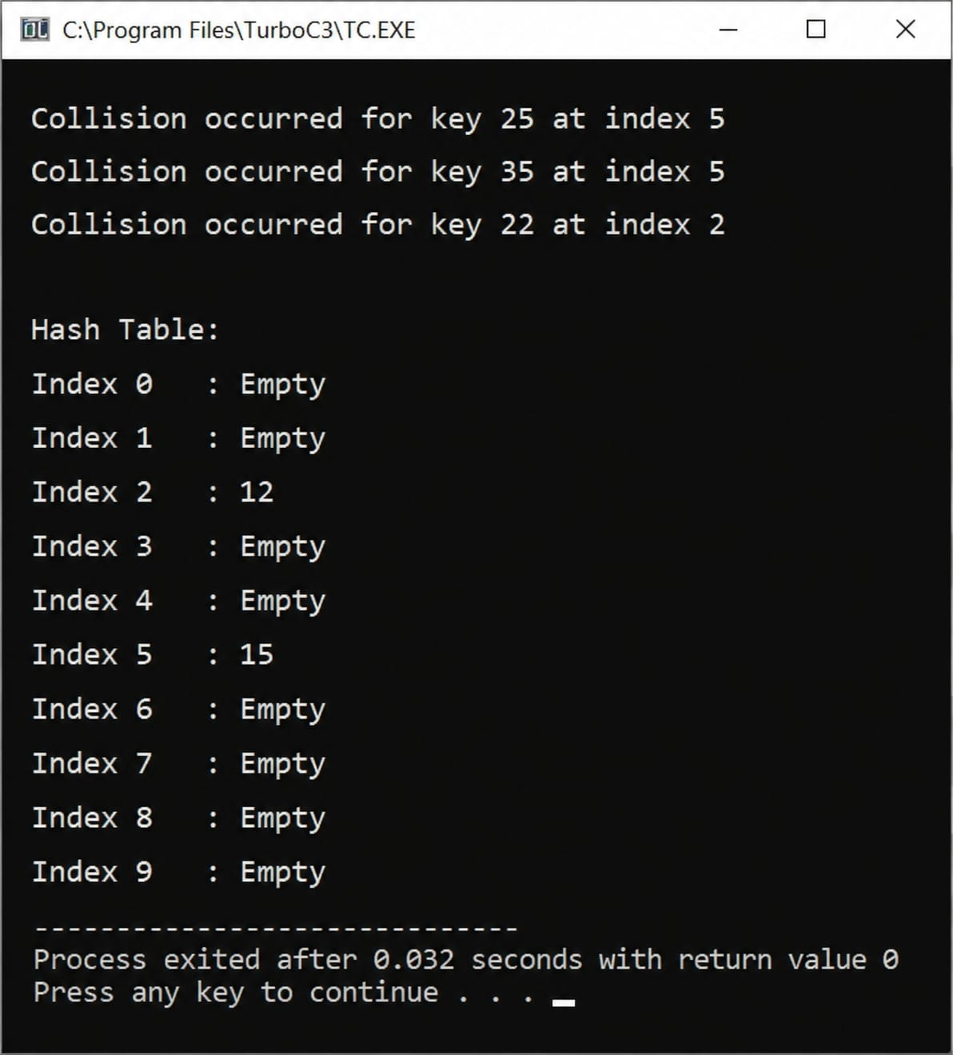

Name: Shruti uday Dhavale Roll No:27

LAB EXERCISE 23

. Implementation of hash collision resolution techniques

- Separate Chaining

#include <stdio.h>
#include <stdlib.h>
#define SIZE 10
struct Node {
int data;
struct Node* next;
};
struct Node* createNode(int value) {
struct Node* newNode = (struct Node*)malloc(sizeof(struct Node));
newNode->data = value;
newNode->next = NULL;
return newNode;
}
void insert(struct Node* table[], int value) {
int index = value % SIZE;
struct Node* newNode = createNode(value);

if (table[index] == NULL) {
table[index] = newNode;
} else {
struct Node* temp = table[index];
while (temp->next != NULL) {
temp = temp->next;
}
temp->next = newNode;
}
}
void display(struct Node* table[]) {
int i;
for (i = 0; i < SIZE; i++) {
struct Node* temp = table[i];
printf("%d: ", i);
while (temp != NULL) {
printf("%d -> ", temp->data);
temp = temp->next;
}
printf("NULL\n");
}
}
void main() {
struct Node* hash_table[SIZE];
int n, value, i;
clrscr();

for (i = 0; i < SIZE; i++) {
hash_table[i] = NULL;
}
printf("Enter number of elements: ");
scanf("%d", &n);

for (i = 0; i < n; i++) {
printf("Enter value: ");
scanf("%d", &value);
insert(hash_table, value);
}
printf("\n--- Separate Chaining Result ---\n");
display(hash_table);
getch();
}
Output:-

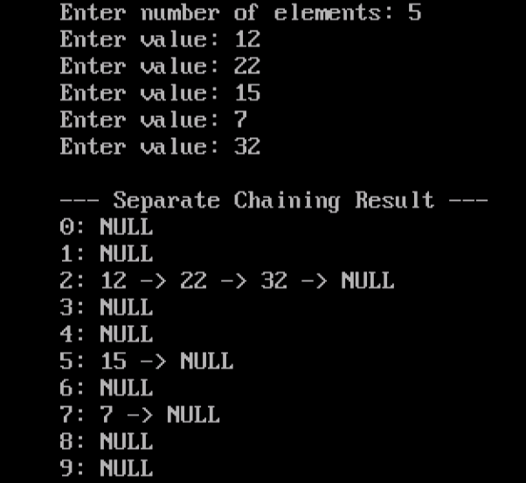

- Linear probing

#include <stdio.h>
#define SIZE 10

int hashTable[SIZE];

void init()
{
int i;
for(i = 0; i < SIZE; i++)
{
hashTable[i] = -1;
}
}

void insert(int key)
{
int index;

index = key % SIZE;

if(hashTable[index] == -1)
{
hashTable[index] = key;
}
else
{
printf("Collision occurred for key %d\n", key);
}
}

void display()
{
int i;

printf("\nHash Table:\n");

for(i = 0; i < SIZE; i++)
{
printf("%d --> %d\n", i, hashTable[i]);
}
}

int main()
{
int n, key, i;

init();

printf("Enter number of elements: ");
scanf("%d", &n);

for(i = 0; i < n; i++)
{
printf("Enter key: ");
scanf("%d", &key);

insert(key);
}

display();

return 0;
}

Output:-

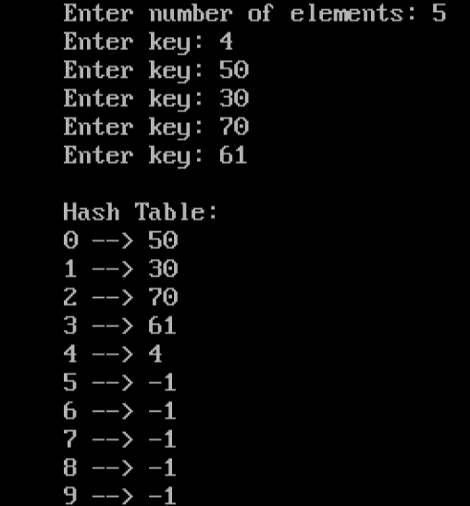

- Quadratic probing

#include <stdio.h>
#define SIZE 10

int hashTable[SIZE];

void init()
{
int i;

for(i = 0; i < SIZE; i++)
{
hashTable[i] = -1;
}
}

int hashFunction(int key)
{
return key % SIZE;
}

void insert(int key)
{
int index = hashFunction(key);
int i = 1;

while(hashTable[index] != -1)
{
index = (hashFunction(key) + i * i) % SIZE;
i++;
}

hashTable[index] = key;
}

void display()
{
int i;

printf("\n--- Hash Table using Quadratic Probing ---\n");

for(i = 0; i < SIZE; i++)
{
printf("%d --> %d\n", i, hashTable[i]);
}
}

int main()
{
int n, key, i;

init();

printf("Enter number of elements: ");
scanf("%d", &n);

for(i = 0; i < n; i++)
{
printf("Enter key: ");
scanf("%d", &key);

insert(key);
}

display();

return 0;
}
Output:-

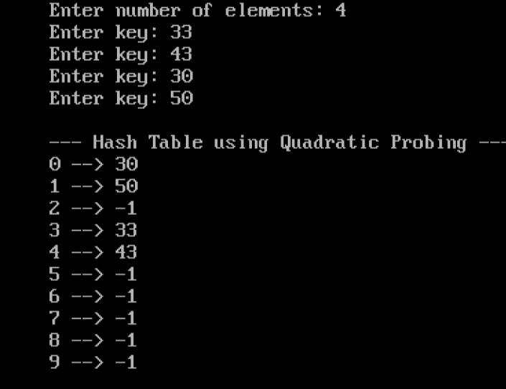

- Double hashing

#include <stdio.h>

#define SIZE 10

int hash_table[SIZE];

// Initialize table with -1
void init() {
for (int i = 0; i < SIZE; i++) {
hash_table[i] = -1;
}
}

// First Hash Function
int h1(int key) {
return key % SIZE;
}
// Second Hash Function
int h2(int key) {
return 7 - (key % 7);
// Insert function using Double Hashing
void insert(int key) {
int index = h1(key);
int i = 1;

// Linear/Double Probing if collision occurs
while (hash_table[index] != -1) {
index = (h1(key) + i * h2(key)) % SIZE;
i++;
if (i == SIZE) {
printf("Table is full! Cannot insert %d\n", key);
return;
}
}
hash_table[index] = key;
}

void display() {
for (int i = 0; i < SIZE; i++) {
printf("Index %d : %d\n", i, hash_table[i]);
}
}

int main() {
init(); // Must call init first!

insert(50);
insert(30);
insert(20);
insert(60);

display();

return 0;
}
Output:-

